**COMPUTER SCIENCE DEPARTMENT**

LAB: Database System

**Lab task # 10**

**Last date of Submission: 25th October 2024**

# Submitted To: Mam Kashia Riaz

**Student Name: UBAID-BIN-WARIS**

# Reg. Number: 2212416

# 

**Task 01**

1. **Write a query to find the names (first_name, last_name) and the salaries of the employees who have a higher salary than the employee whose last_name = 'Bull'.**

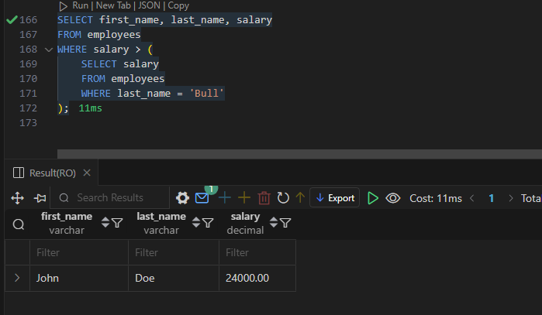

1. **Write a query to find the names (first_name, last_name) of all employees who work in the IT department.**

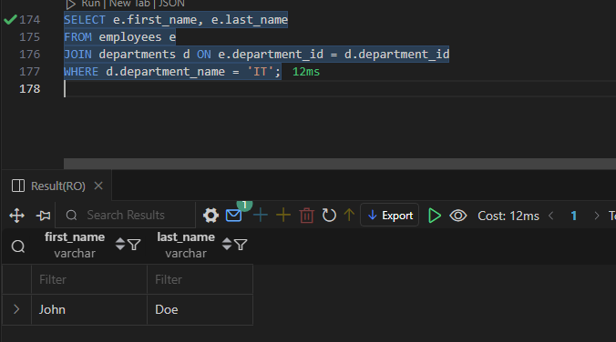

1. **Write a query to find the names (first_name, last_name) of the employees who have a manager and work for a department based in the United States.**

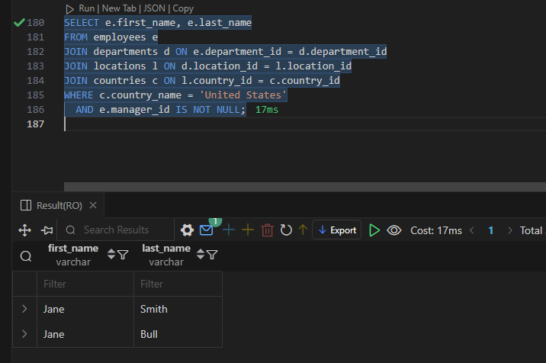

1. **Write a query to find the names (first_name, last_name) of the employees who are managers.**

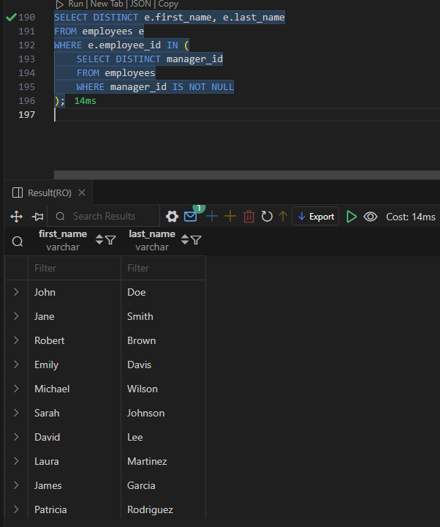

1. **Write a query to find the names (first_name, last_name), the salary of the employees whose salary is greater than the average salary.**

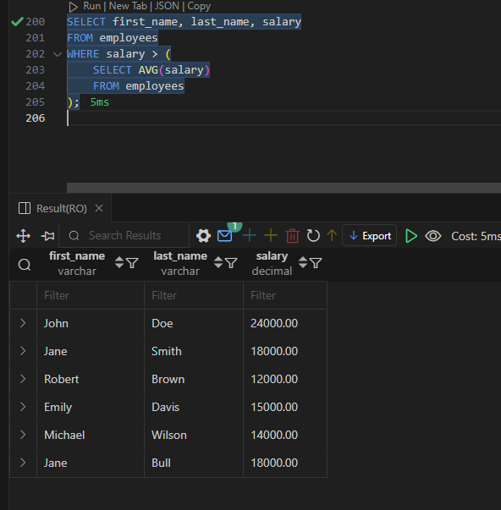

1. **Write a query to find the names (first_name, last_name), the salary of the employees whose salary is equal to the minimum salary for their job grade.**

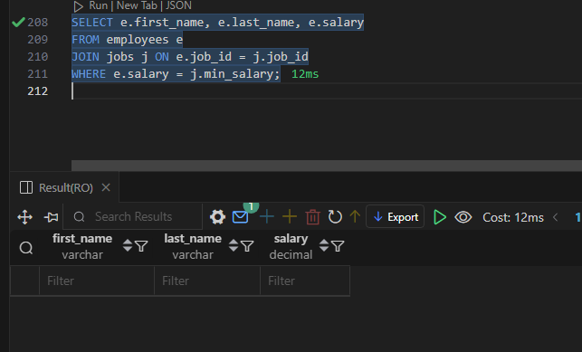

1. **Write a query to find the names (first_name, last_name), the salary of the employees who earn more than the average salary and who work in any of the IT departments.**

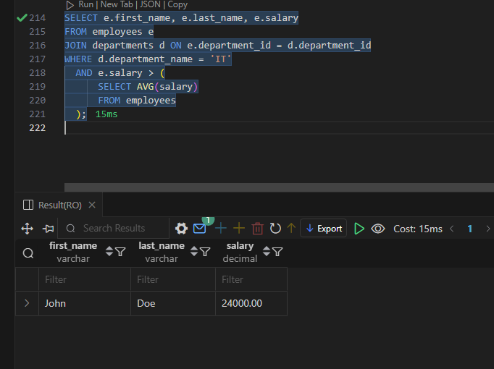

1. **Write a query to find the names (first_name, last_name), the salary of the employees who earn more than Mr. Bell.**

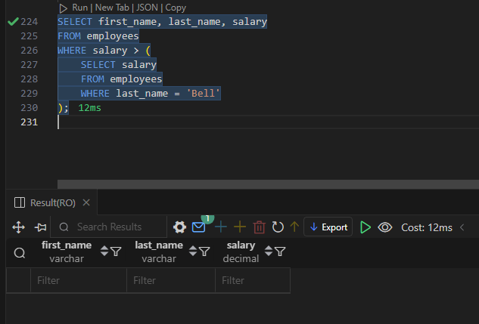

**Task 02**

1. **Write a query to find the addresses (location_id, street_address, city, state_province, country_name) of all the departments.**

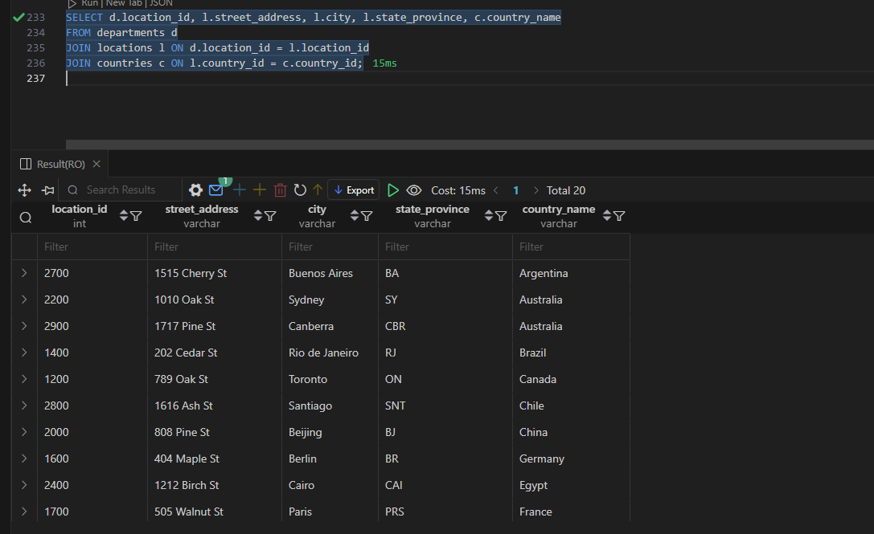

1. **Write a query to find the names (first_name, last_name), department ID, and name of all the employees.**

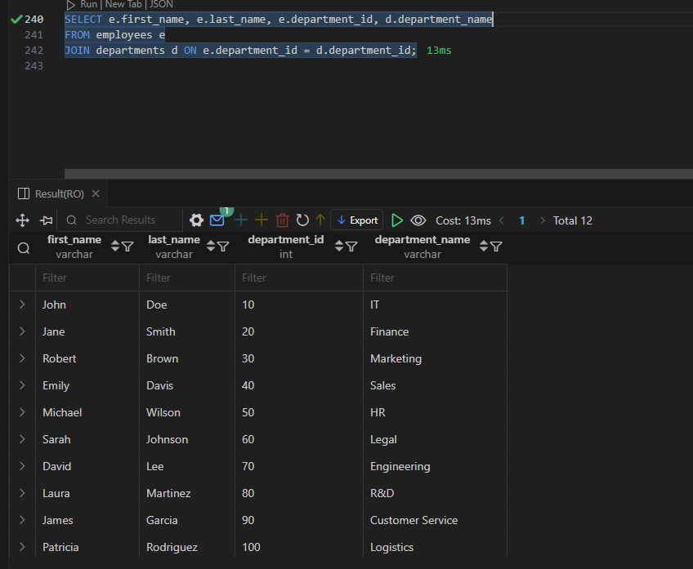

1. **Find the names (first_name, last_name), job, department number, and department name of the employees who work in London.**

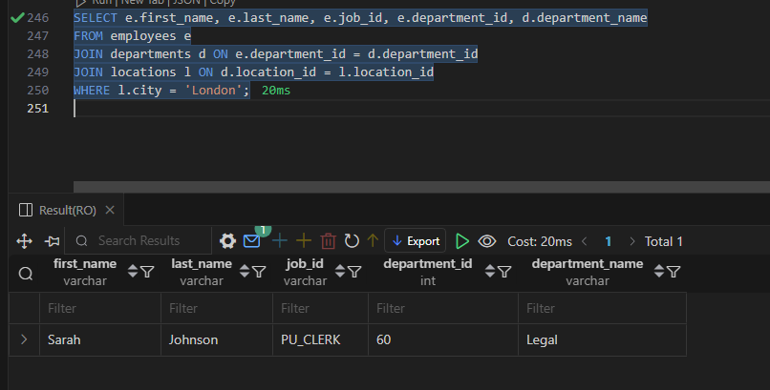

1. **Write a query to find the employee ID, name (last_name) along with their manager_id, and manager name (last_name).**

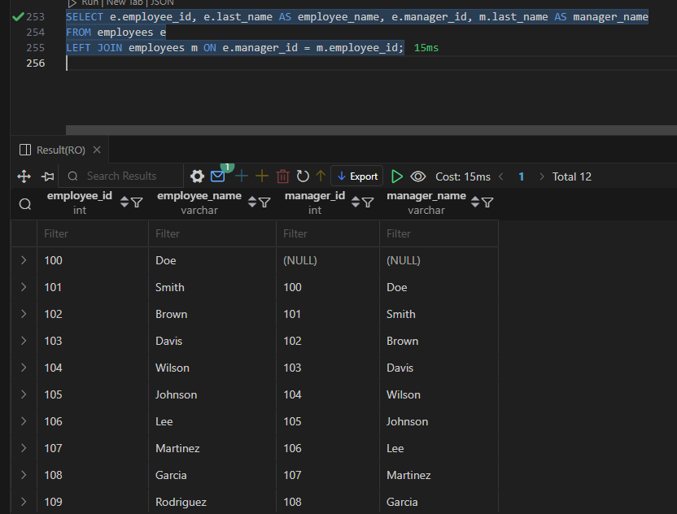

1. **Find the names (first_name, last_name) and hire date of the employees who were hired after 'Jones'.**

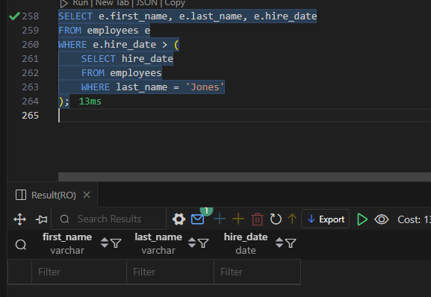

1. **Write a query to get the department name and the number of employees in the department.**

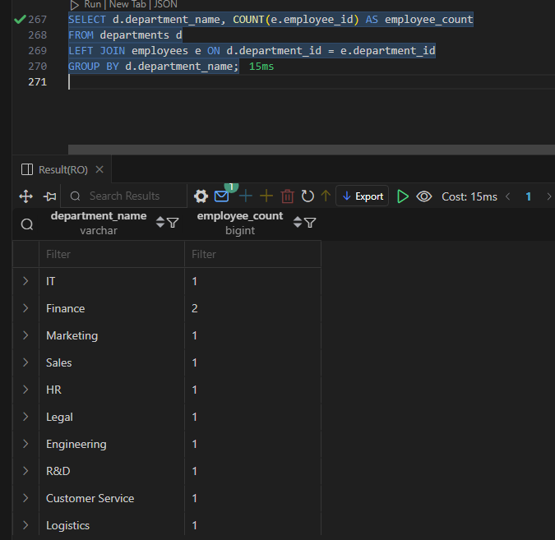

1. **Find the employee ID, job title, and the number of days between the ending date and starting date for all jobs in department 90 from job history.**

**WILL BE EXPLAIN IN CLASS ! ! !**

1. **Write a query to display the department ID, department name, and manager first name.**

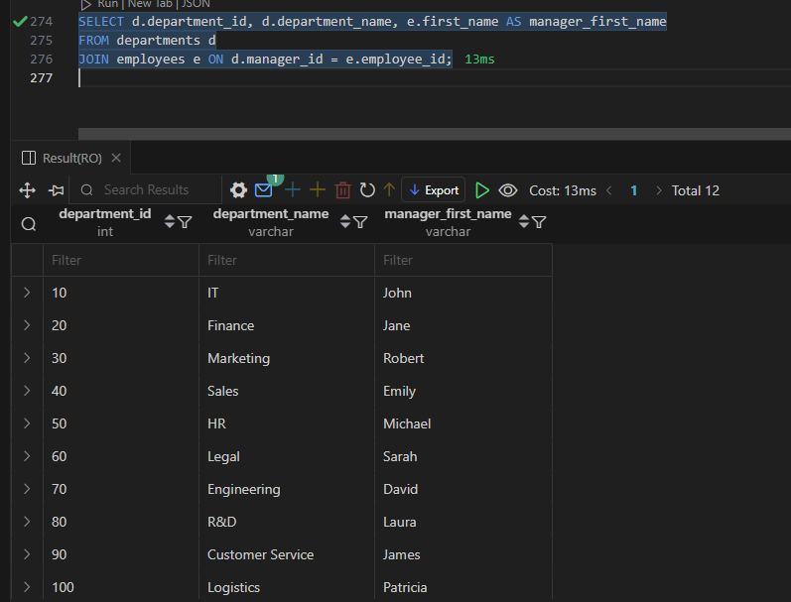

1. **Write a query to display the department name, manager name, and city.**

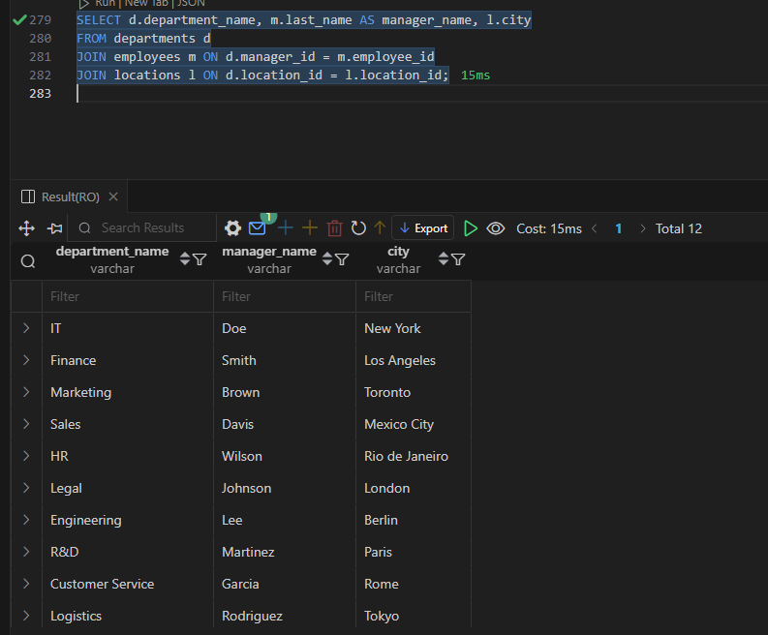

1. **Write a query to display the job title and the average salary of employees.**

